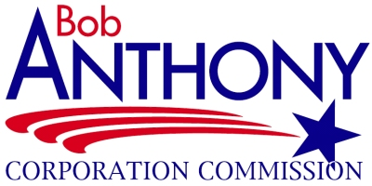

Among the nine Oklahoma offices currently elected statewide, Commissioner Bob Anthony has served longer than any other Oklahoma office holder in state history. He won his sixth consecutive six-year term to the Oklahoma Corporation Commission in 2018, carrying all 77 counties just as he did in 2012. He initially ran for Corporation Commissioner in 1988, becoming the first Republican elected to that body in 60 years and receiving more votes than any Republican since statehood. In 1994, Anthony became the first Republican incumbent in Oklahoma history to win statewide re-election to a state office. In 2000, he was re-elected, receiving more votes at that time than any candidate for state office in Oklahoma history.

Bob Anthony has served six times as chairman of the Oklahoma Corporation Commission. He is a member of the board of directors for the National Association of Regulatory Utility Commissioners and past chairman of the National Regulatory Research Institute. He is currently the longest serving utility commissioner in the United States.

Anthony is a member of the National Petroleum Council, having been appointed five times by the United States Secretary of Energy. He is past president of the Mid-America Regulatory Conference, a member and past president of the Economic Club of Oklahoma, and for eight years, was a delegate to the worldwide General Conference of the United Methodist Church.

Anthony holds a BS from the Wharton School of Finance at the University of Pennsylvania; a Master of Science from the London School of Economics; a Master of Arts from Yale University; and a Master of Public Administration from Harvard University. He rose to the rank of captain in the U.S. Army Reserve. In 1972, he served as staff economist for the Committee on Interior and Insular Affairs of the U. S. House of Representatives (now called the Natural Resources Committee). From 1979 to 1980, Anthony served on the Oklahoma City Council as Ward 2 Councilman and then as vice mayor. In 1980, at age thirty-two, Anthony became president of C.R. Anthony Company retail stores, then the largest privately-owned firm headquartered in Oklahoma. During his seven-year term as president, annual sales for the retail chain increased from $256 million to $411 million, with payroll, employment, and dollar profits reaching all-time record levels. In 1988 he was chairman of the Trust Committee of Oklahoma’s largest bank trust department.

In 1995, the Federal Bureau of Investigation honored Anthony with its highest award given to a citizen who “at great personal sacrifice, has unselfishly served his community and the nation.” Among other recognitions, the AARP of Oklahoma presented Anthony with an award “in appreciation of his tireless efforts on behalf of Oklahoma consumers.”

All four of Anthony’s grandparents came to Oklahoma before statehood. His father was born in Cleveland, Oklahoma, and his mother grew up in Enid, Oklahoma. He and his wife Nancy were married in 1975. They are the parents of four daughters and have five grandchildren.

Last updated: Feb. 2019

